

PLANO DE AULA
Aula 10 | Tempo estimado: 1 hora e 30 minutos | Faixa-Etária: Game Advanced
Tipo da atividade: No computador
Ferramenta(s): Unity 3D

Conteúdos
- Combate do NPC - Parte 2

Objetivos
- Configurar sistema de combate do NPC.

Estratégias e atividades

Para dar continuidade ao sistema de combate do NPC que iniciamos na aula anterior, vamos fazer alterações importantes no script para integrar a lógica de ataque com o sistema de navegação e comportamento já implementado. Vamos adicionar o controle de cooldown de ataques, detecção de distância e a execução dos diferentes tipos de ataque.

START

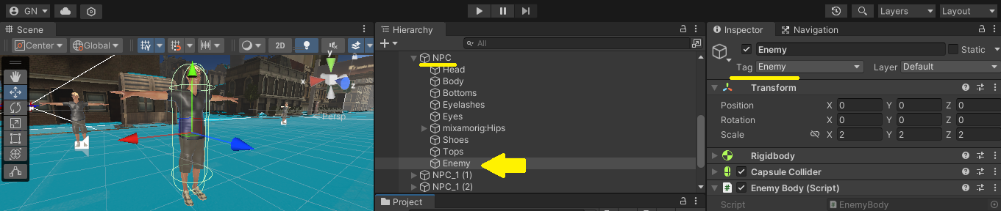

Vamos atualizar o script do NPC com o sistema de ataque:

using System.Collections;
using System.Collections.Generic;
using System.Linq;
using Unity.VisualScripting;
using UnityEngine;
using UnityEngine.AI;
using static Player;

public class NPC : MonoBehaviour
{
public enum NPCState
{
Passive,
Agressive,
Equipped,
Dead
}

[Header("NPC Status")]
public NPCState state;
[SerializeField]
public float health = 100f;
public bool isDead;
public bool isAttacking;
public bool isHit;

[Header("Animation")]
public Animator anim;
public RuntimeAnimatorController passiveController;
public RuntimeAnimatorController enemyController;

[Header("Combat")]
public GameObject player;
public float lastAttackTime;
public float attackCooldown = 3f;
public float attackDistance = 1f;
[SerializeField]
public bool isAgressive;

[Header("IA")]
public NavMeshAgent agent;
public Transform patrolGroup;
public Transform[] patrolPoints;
private int currentPatrolPointIndex;

void Start()
{
isDead = false;
isAttacking = false;
isHit = false;

patrolPoints = new Transform[patrolGroup.childCount];
for (int i = 0; i < patrolGroup.childCount; i++)
{
patrolPoints[i] = patrolGroup.GetChild(i);
}

currentPatrolPointIndex = Random.Range(0, patrolGroup.childCount);

state = NPCState.Passive;
agent.SetDestination(patrolPoints[currentPatrolPointIndex].position);
}

void Update()
{
if (!isDead)
{
anim.SetFloat("Velocity", agent.velocity.magnitude);

switch (state)
{
case NPCState.Passive:
anim.runtimeAnimatorController = passiveController;
Passive();
break;
case NPCState.Agressive:
anim.runtimeAnimatorController = enemyController;
Agressive();
break;
case NPCState.Dead:
Die();
break;
}

if (isAgressive && player.GetComponent<Player>().state == PlayerState.Agressive)
{
state = NPCState.Agressive;
}
}
else
{
anim.SetBool("isDead", true);
}
}

public void Passive()
{
if (!agent.pathPending && agent.remainingDistance < 0.1f)
{
currentPatrolPointIndex++;
if (currentPatrolPointIndex < patrolPoints.Count())
{
agent.SetDestination(patrolPoints[currentPatrolPointIndex].position);
}
else
{
currentPatrolPointIndex = 0;
}
}

if(player.GetComponent<Player>().state == PlayerState.Agressive)
{
Fear();
}
}

public void Fear()
{
agent.speed = 5f;
}

public void Agressive()
{
float distanceToPlayer = Vector3.Distance(transform.position, player.transform.position);

Quaternion targetRotation = Quaternion.LookRotation(player.transform.position - transform.position);
transform.rotation = Quaternion.Slerp(transform.rotation, targetRotation, 0.1f);

if (player.GetComponent<Player>().isDead || distanceToPlayer > 30.0f)
{
currentPatrolPointIndex = Random.Range(0, patrolGroup.childCount);

state = NPCState.Passive;
agent.SetDestination(patrolPoints[currentPatrolPointIndex].position);
agent.isStopped = false;
agent.speed = 2f;
}
else
{
if (isAttacking || isHit)
{
agent.isStopped = true;
}
else
{
agent.isStopped = false;
agent.speed = 2f;
agent.SetDestination(player.transform.position);

if (distanceToPlayer <= attackDistance)
{
agent.isStopped = true;

if (!isAttacking && !isHit && Time.time >= lastAttackTime + attackCooldown)
{
lastAttackTime = Time.time;
int enemyAction = Random.Range(1, 10);

if (enemyAction == 1)
{
anim.SetTrigger("Attack1");
}
else if (enemyAction == 2)
{
anim.SetTrigger("Attack2");
}
else
{
lastAttackTime += 2f;
}
}
}
}
}
}

public void Die()
{
isDead = true;
anim.SetTrigger("Death");
agent.isStopped = true;
}

public void HitDamage(float damage)
{
health -= damage;

if (health <= 0f)
{
state = NPCState.Dead;
player.GetComponent<Player>().enemyGroup.Remove(gameObject);
player.GetComponent<Player>().SetEnemyFocus();
return;
}
else
{
isHit = true;
anim.SetTrigger("Hit");
}
}

public void BeginAttack()
{
isAttacking = true;
}

public void EndAttack()
{
isAttacking = false;
}

public void EndHit()
{
isHit = false;
}

public void EndDeath()
{
Destroy(gameObject, 5f);
}
}

Assim como fizemos para o Player, vamos adicionar eventos em pontos específicos das animações: BeginAttack, EndAttack, EndHit e EndDeath:

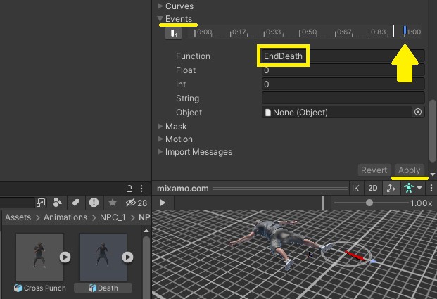

Ao final, lembre-se de atualizar as referências de objeto nos scripts NPC e EnemyBody.

Recursos
- Computador, internet e Unity.

Observação
- Os assets e scripts estão disponíveis no Google Drive;
- Link para o download da Unity:
  - https://unity.com/pt/download
- Para as tarefas:

Tarefa
- Sem tarefa.

